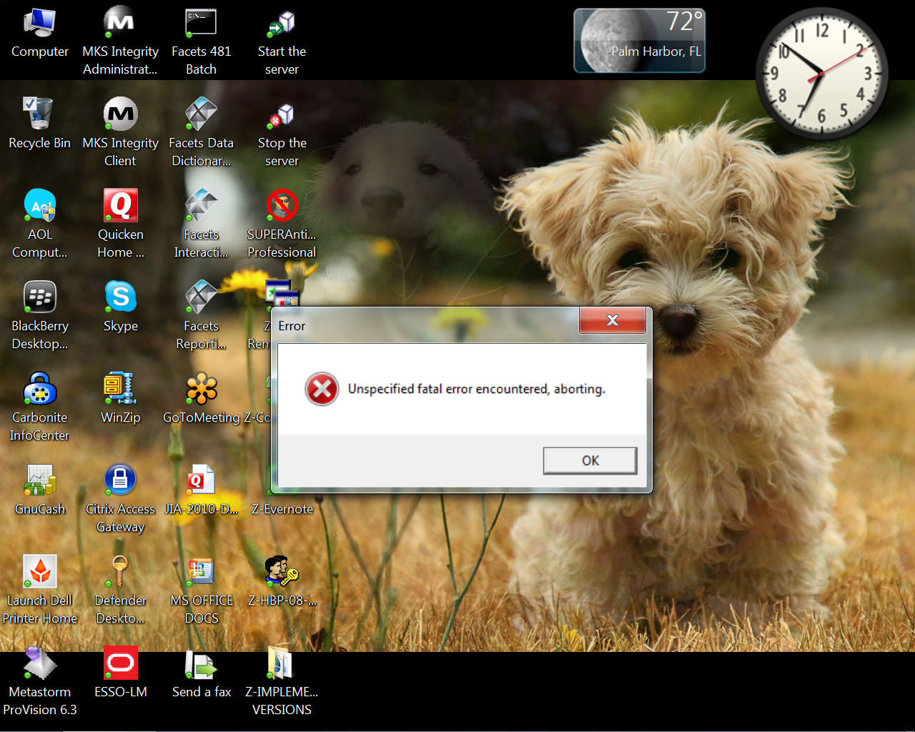
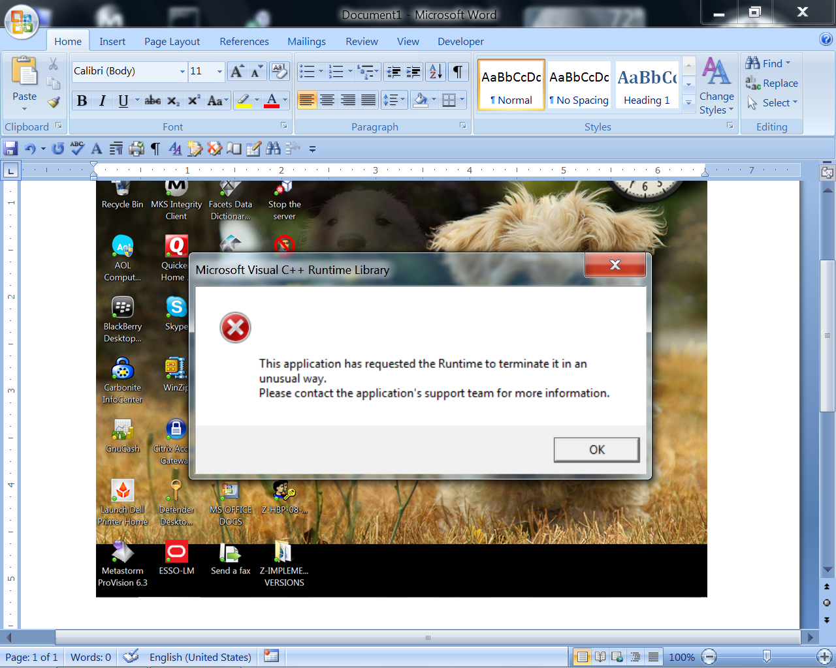
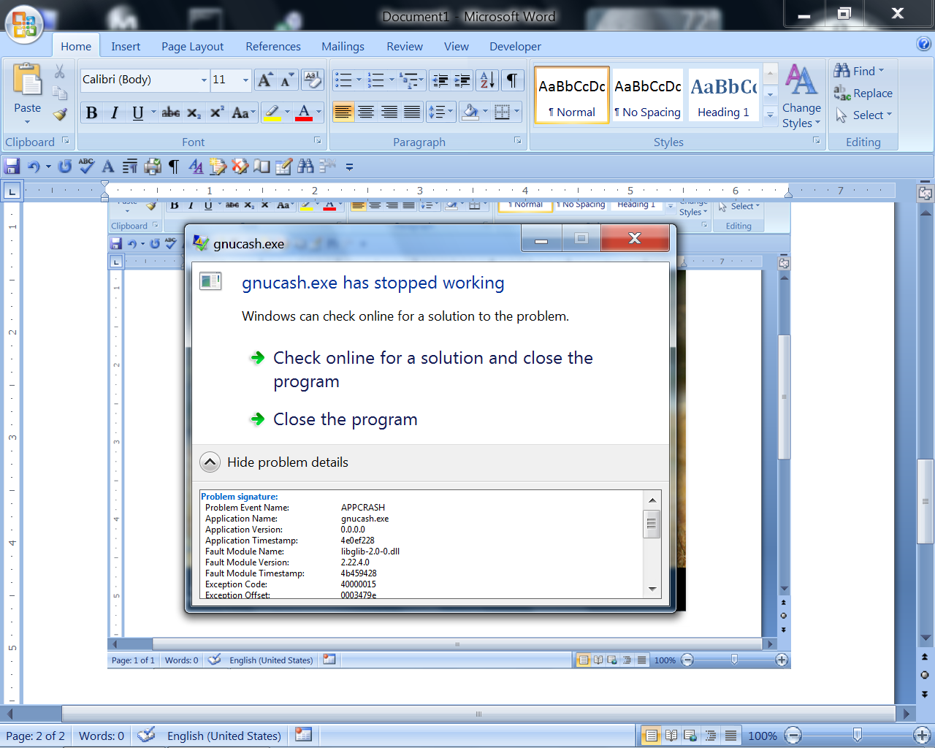
Problem signature:
Problem Event Name: APPCRASH
Application Name: gnucash.exe
Application Version: 0.0.0.0
Application Timestamp: 4e0ef228
Fault Module Name: libglib-2.0-0.dll
Fault Module Version: 2.22.4.0
Fault Module Timestamp: 4b459428
Exception Code: 40000015
Exception Offset: 0003479e
OS Version: 6.1.7601.2.1.0.256.4
Locale ID: 1033
Additional Information 1: 9f0e
Additional Information 2: 9f0ef69b21ffbfd1ba28f5e71ebbb0fe
Additional Information 3: 5b9b
Additional Information 4: 5b9bf3ae215c53c5104a33d8a4f12129

Read our privacy statement online:
http://go.microsoft.com/fwlink/?linkid=104288&clcid=0x0409

If the online privacy statement is not available, please read our privacy statement offline:
C:\Windows\system32\en-US\erofflps.txt

