When I open
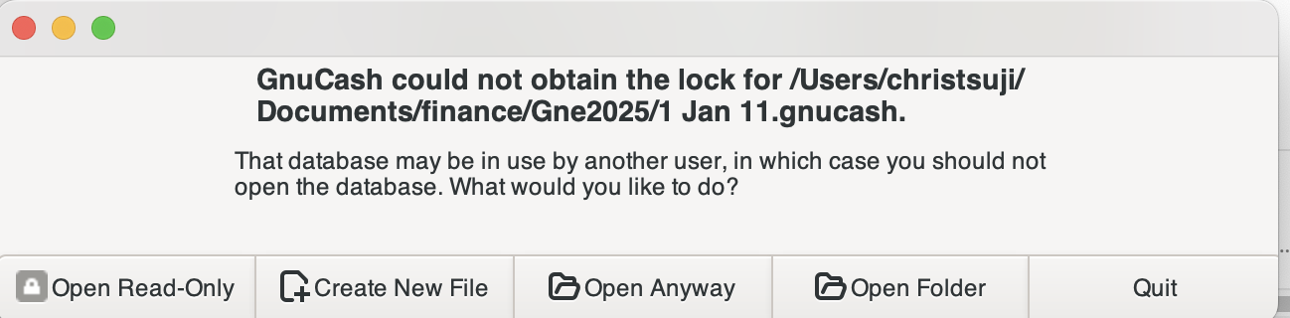
When I click on open anyway
I get an error Gnucash quit unexpectedly
Then I click on reopen, and the above come up.
I then use open folder and find the gnucash file and click on it, and it goes back to the above.
Attempted to open the file by clicking on it, but again goes to the above

Tried to obtain gnucash v5.10 but after downloading, I get a circle with a line across the circle.
Dragged to the hard disk and receive the error that is it not supported on this mac.
