NPSNAV
Finance::Quote module for India NPS fund NAVs
Deployment & Price-Fetching Guide (GnuCash on Windows / Strawberry Perl)
Data source: npsnav.in

1. Overview
NPSNAV is a custom Finance::Quote module that fetches the latest Net Asset Value (NAV) of Indian National Pension System (NPS) fund schemes from npsnav.in, so that NPS holdings can be tracked as securities in GnuCash (or any other Finance::Quote consumer) with automatic price updates.
This guide covers three things:
- Placing the module files in the correct Strawberry Perl folders.
- Registering NPSNAV as a known quote source inside Finance::Quote.
- Setting up a security in GnuCash and fetching its price.
Prerequisite
Strawberry Perl must already be installed on the machine, with Finance::Quote available under its site library (e.g. C:\Strawberry\perl\site\lib\Finance).

2. Files You Need
File | Purpose
NPSNAV.pm | The module itself — fetches and parses NAV data from npsnav.in.
Quote.pm | Finance::Quote's master module list — must be edited so it knows NPSNAV exists.

3. Deployment Steps

3.1 Place NPSNAV.pm in the Finance::Quote folder
Copy NPSNAV.pm into the Finance\Quote sub-folder of your Strawberry Perl site library, alongside the other quote source modules (IndiaMutual, MarketWatch, NSEIndia, etc.):
C:\Strawberry\perl\site\lib\Finance\Quote\NPSNAV.pm
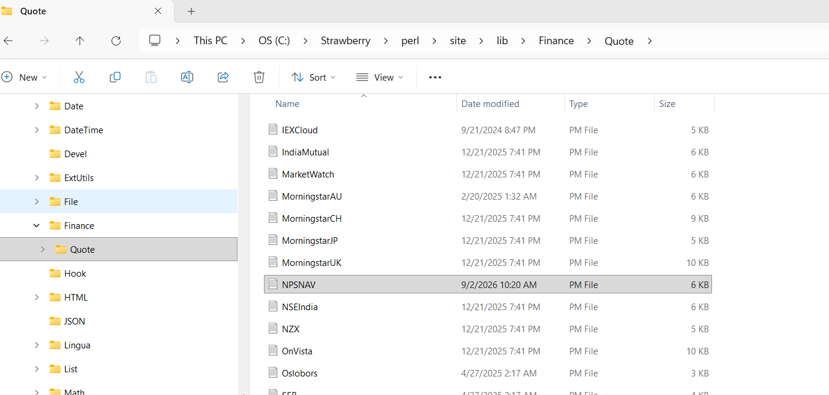
Figure 1 — NPSNAV.pm placed in C:\Strawberry\perl\site\lib\Finance\Quote\, next to the other Finance::Quote source modules.

3.2 Register NPSNAV inside Quote.pm
Finance::Quote keeps a master list of every available quote-source module in Quote.pm, one directory level up from the Quote\ sub-folder:
C:\Strawberry\perl\site\lib\Finance\Quote.pm
Open it in a text/code editor and find the @MODULES list. Add a new line with:
NPSNAV
in alphabetical order among the other module names (it sits naturally between NSEIndia and OnVista). Save the file.
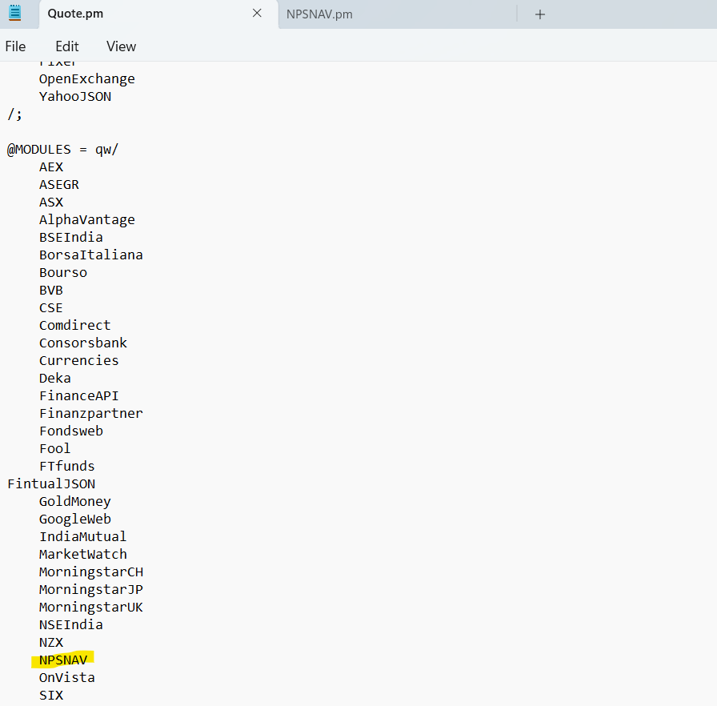
Figure 2 — NPSNAV added to the @MODULES list in Quote.pm, alongside, IndiaMutual, NSEIndia and the others.
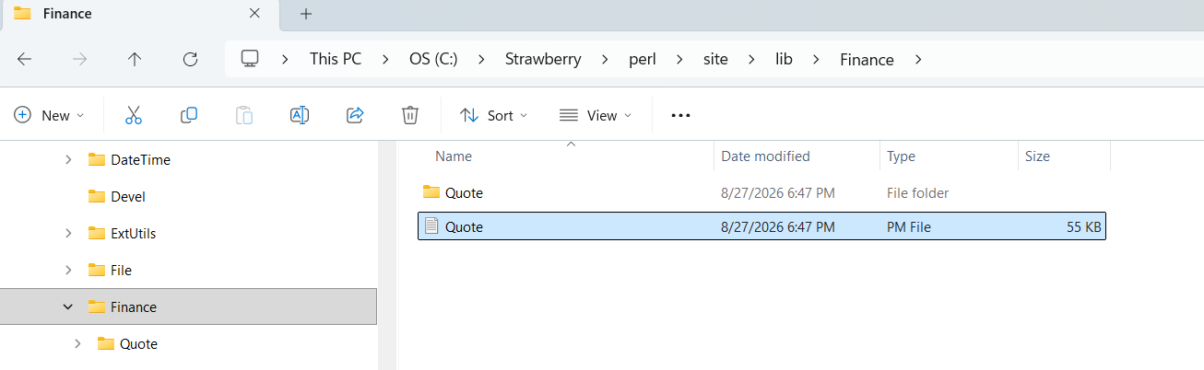
Figure 3 — Quote.pm sits directly inside C:\Strawberry\perl\site\lib\Finance\ (one level above the Quote\ folder).
Why this step matters
Finance::Quote only loads modules that are explicitly listed in @MODULES. Placing NPSNAV.pm in the Quote folder is not enough on its own — without this edit, Finance::Quote will not know the "npsnav" source exists.

4. Setting Up a Security in GnuCash
Once the two files above are in place, start (or restart) GnuCash so it picks up the new module. Then create a security for each NPS scheme you want to track.

4.1 Open the Security Editor
- In GnuCash, go to Tools → Security Editor.
- Click Add to create a new security. (Optional) Create a new Namespace such as INDIA to group all NPS schemes together for clarity — this is what was used in the example below.
- Fill in the security details:
Field | Value
Full name | The scheme's full name, e.g. HDFC SCHEME E - TIER I GS
Symbol / abbreviation | The NPS scheme code, e.g. SM008015
Display symbol | Same scheme code, e.g. SM008015
Namespace | INDIA (or any namespace you prefer)
- Tick Get Online Quotes.
- Under Type of quote source, select the Unknown radio button.
- From the dropdown next to Unknown, select npsnav.
- Click OK to save the security.
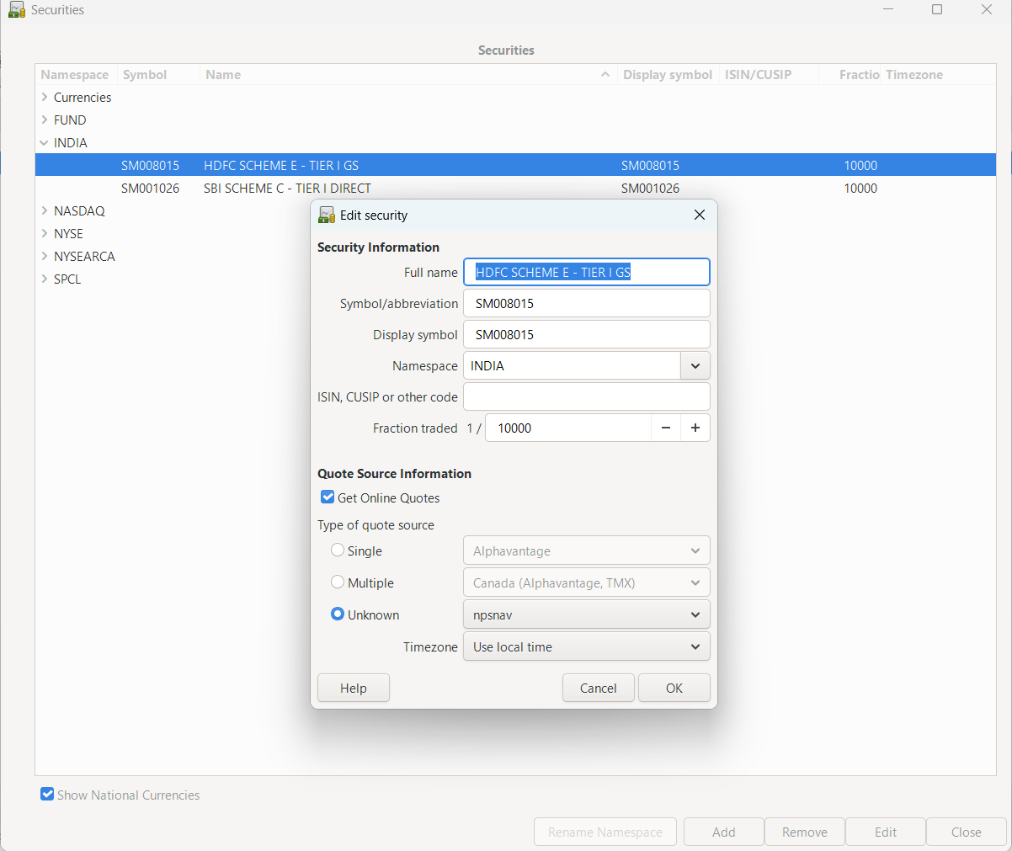
Figure 4 — Security editor: symbol set to the scheme code (SM008015), namespace INDIA, Unknown quote source type with npsnav selected.
Important
The Symbol/abbreviation field must be the exact NPS scheme code (e.g. SM001026, SM008015) — this is what NPSNAV.pm sends to npsnav.in to fetch the NAV.

5. Fetching Prices
- Go to Tools → Price Database.
- Select the security (or securities) you want to update, or leave nothing selected to update all.
- Click Get Quotes.
- GnuCash calls Finance::Quote in the background, which runs NPSNAV.pm against npsnav.in for each scheme code and returns the latest NAV.
- A new row appears for each security showing Currency (INR), Date, Source (Finance::Quote), Type (last) and Price — the fetched NAV.
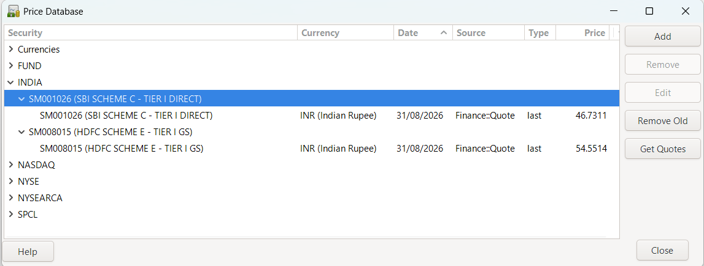
Figure 5 — Price Database after Get Quotes: SM001026 and SM008015 both show a fresh INR price fetched via Finance::Quote.

6. Troubleshooting
Symptom | Likely Cause / Fix
"Can't use string (...) as a HASH ref" error | NPSNAV.pm was pointed at the plain-text NAV endpoint instead of the detailed JSON endpoint. Confirm the module uses https://npsnav.in/api/detailed/ as its base URL.
npsnav does not appear in the quote-source dropdown | Quote.pm was not edited, or GnuCash was not restarted after editing it. Re-check the @MODULES list and restart GnuCash.
Get Quotes returns nothing for a security | Check that the Symbol/abbreviation field exactly matches a valid npsnav.in scheme code, and that the machine has internet access to npsnav.in.

7. Quick Reference
Item | Path / Value
Module file | C:\Strawberry\perl\site\lib\Finance\Quote\NPSNAV.pm
Module list | C:\Strawberry\perl\site\lib\Finance\Quote.pm (@MODULES → add NPSNAV)
Quote source name (GnuCash) | npsnav
Data source | npsnav.in — Detailed Fund Data API
Symbol format | NPS scheme code, e.g. SM001026, SM008015
Default currency | INR

